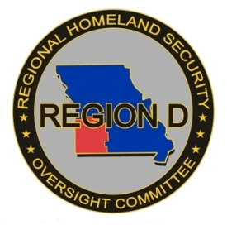
REGION D RHSOC QUARTERLY MEETING
Wednesday, July 17, 2019
9:00 A.M.
MU Southwest Research Center
14548 Highway H, Mount Vernon, MO

MEETING AGENDA

Open Meeting David Hall
- Opening Comments/Pledge of Allegiance
- Roll Call/Introductions
- Approval of Consent Agenda
JULY 17, 2019 MEETING AGENDA
MINUTES OF APRIL 17, 2019 MEETING
(RHSOC ACTION REQUESTED TO APPROVE CONSENT AGENDA)

Committee Reports
- RHSOC Chair Meeting David Hall
- Exercise/Training Report Melissa Duckworth
- TICP Working Group Jonathan Ayres
- Strategic Plan Working Group Ted Martin

Old Business
- SHSP Procurement Updates Dorothy Wittorff-Sandgren
- Cybersecurity David Hall
- Inventory Requests Dorothy Wittorff-Sandgren

New Business
- Scoring of FY19 SHSP Applications David Hall
RHSOC ACTION REQUESTED TO APPROVE ALLOCATIONS FOR FY2018 REGIONAL HOMELAND SECURITY GRANT AND AUTHORIZE THE SOUTHWEST MISSOURI COUNCIL OF GOVERNMENTS TO SUBMIT THE RESULTS TO THE OFFICE OF HOMELAND SECURITY.

Federal / State / Regional Partners
- OHS Update - HSAC & Other Initiatives Michelle Branson
- Homeland Security Grants Update Michelle Branson
- Interoperable Communications Bryan Courtney
- DHSS Update Douglas Baker
- DNR Update Wendell Hall
- Agriculture Dr. Larry Forgey
- Mutual Aid Matt Luetkemeyer, Kevin Virgin
- Incident Support Team Scott Moore

Disciplinary Group Reports

Other Business/Open Discussion
- Annual Meeting Dorothy Wittorff-Sandgren

Next Meeting Date

Adjourn

