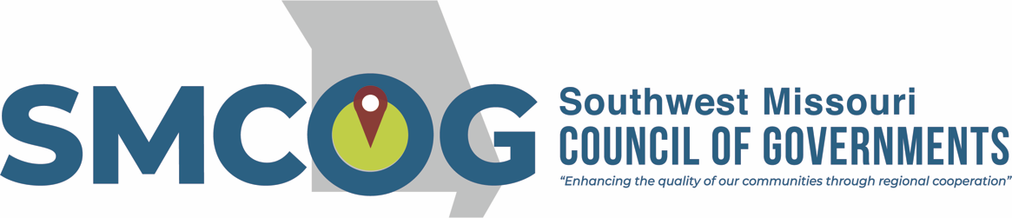

**Southwest Missouri Council of Governments**

**Executive Committee Meeting**

**Tuesday, July 9, 2024**

**3:00 p.m.**

Alumni Center 2nd Floor Conference Room  
300 S. Jefferson Ave., Springfield, MO

[**Virtual option via Zoom**](https://missouristate.zoom.us/j/5364440829?pwd=MlUzbmJKSXllVENpRndadjlEMThmZz09)

**MEETING AGENDA**

1. Approval of July 9, 2024 Agenda
2. Approval of June 11, 2024 Minutes
3. Bank Transfers
4. MSU Administration Agreement
5. Pierce City LMI Survey Contract
6. Ozarks Film Commission Update
7. Program/Project Updates  
   Professional Liability Insurance  
   CFI Grant Proposal  
   SS4A Award Negotiations  
   Broadband Breakthrough – 12 statewide – Dade, Polk, Dallas  
   RAISE Application was NOT awarded
8. Adjourn

This meeting is open to the public in accordance with Missouri law. A copy of this agenda was posted for public view at the SMCOG office at 110 Park Central Square, Springfield, MO 65806 on July 8, 2024 and online at smcog.org.

SMCOG complies with Title VI of the Civil Rights Act of 1964 and related statutes and regulations in all programs and activities. For more information or to obtain a Title VI Complaint Form, see [www.smcog.org](http://www.smcog.org), or call (417) 836-6900. Persons who require special accommodations under the Americans with Disabilities Act or persons who require translation services (free of charge) should contact Jane Hood at (417) 836-6273 at least 4 working days prior to the meeting date.