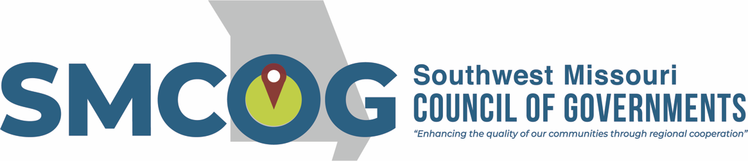

Southwest Missouri Council of Governments
Executive Committee Meeting
Tuesday, February 13, 2024
3:00 p.m.
Alumni Center 2nd Floor Conference Room
300 S. Jefferson Ave., Springfield, MO

MEETING AGENDA

- Approval of February 13, 2024 Agenda

- Approval of January 9, 2024 Minutes

- Financial Report

- Bank Transfers

- Program/Project Updates

- Adjourn

This meeting is open to the public in accordance with Missouri law. A copy of this agenda was posted for public view at the SMCOG office at 110 Park Central Square, Springfield, MO 65806 on February 12, 2024 and online at smcog.org.
SMCOG complies with Title VI of the Civil Rights Act of 1964 and related statutes and regulations in all programs and activities. For more information or to obtain a Title VI Complaint Form, see www.smcog.org, or call (417) 836-6900. Persons who require special accommodations under the Americans with Disabilities Act or persons who require translation services (free of charge) should contact Jane Hood at (417) 836-6273 at least 4 working days prior to the meeting date.

