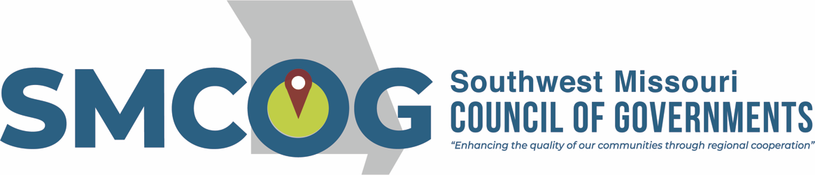

Southwest Missouri Council of Governments
Executive Committee Meeting
Tuesday, May 9, 2023
3:00 p.m.
Alumni Center 2nd Floor Conference Room
300 S. Jefferson Ave., Springfield, MO

MEETING AGENDA

- Approval of May 9, 2023 Agenda

- Approval of February 14, 2023 Minutes

- Approve MO Office of Administration State Aid Application
  - Due June 1

- Authorize FY24 MoDOT Application and Local Match
  - Work Plan Due May 21

- Authorize MoDHSS Active Transportation Application (if awarded)
  - Kimberling City Active Transportation Plan
  - Submitted April 28

- Approve Coney Island Planning Services Contract

- Approve Bank Transfers
- FY24 Budget Discussion
Audit Update will need to get bids for FY23 (and next few years?)

- Program/Project Updates
2 out of 4 604(b) projects funded
Greene County ARPA projects awarded!
Aurora Comp plan finalized
RLF Agreement with SGF
Hiring Economic Development Planner
CFO Regionalism discussion

- Other Business
SGF Chamber Agreement
Fiscal Policy
SS4A – July 10 – Kimberling City vs. Regional
StreetLight
Ask Todd to respond about Transportation prioritization mtg – Aishwarya
Local Govt Week

- Adjourn

This meeting is open to the public in accordance with Missouri law. A copy of this agenda was posted for public view at the SMCOG office at 110 Park Central Square, Springfield, MO 65806 on May 5, 2023 and online at smcog.org.
SMCOG complies with Title VI of the Civil Rights Act of 1964 and related statutes and regulations in all programs and activities. For more information or to obtain a Title VI Complaint Form, see www.smcog.org, or call (417) 836-6900. Persons who require special accommodations under the Americans with Disabilities Act or persons who require translation services (free of charge) should contact Jane Hood at (417) 836-6273 at least 4 working days prior to the meeting date.

